1. **Arduino Pro Mini 5v 16Mhz variant**

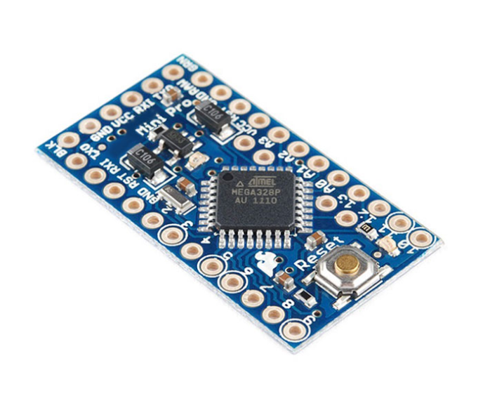

1. **USB to TTl CP2102 6pin with DTR**

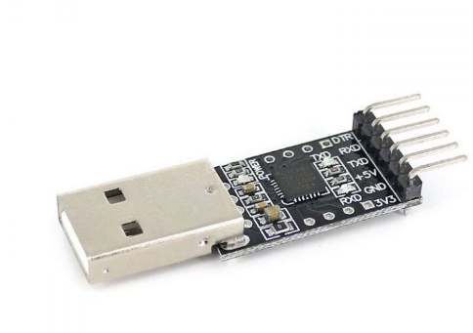

1. **Curved Male to Male header pins**

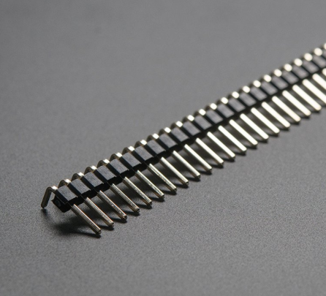

1. **MLX90614 Infrared Temperature Sensor**

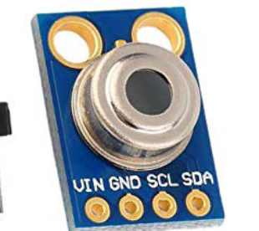

1. **OLED Display Module (SPI/I2C) 7 pin – SSD1306**

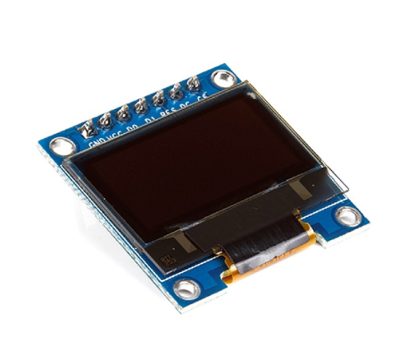

1. **Laser Diode**

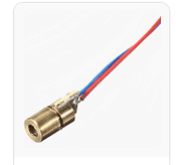

1. **9V Battery - Get two**

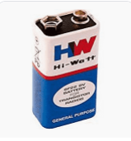

1. **Battery Clip for 9v battery**

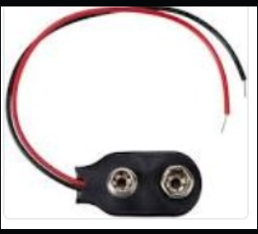

1. **Push button**

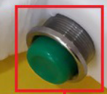

1. **Glue Stick for glue gun – Get three**

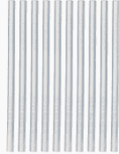

1. **Heat shrink for Single Strand wire**

